Name:Jackie Zhang  Tutorial Group ID: T13 | 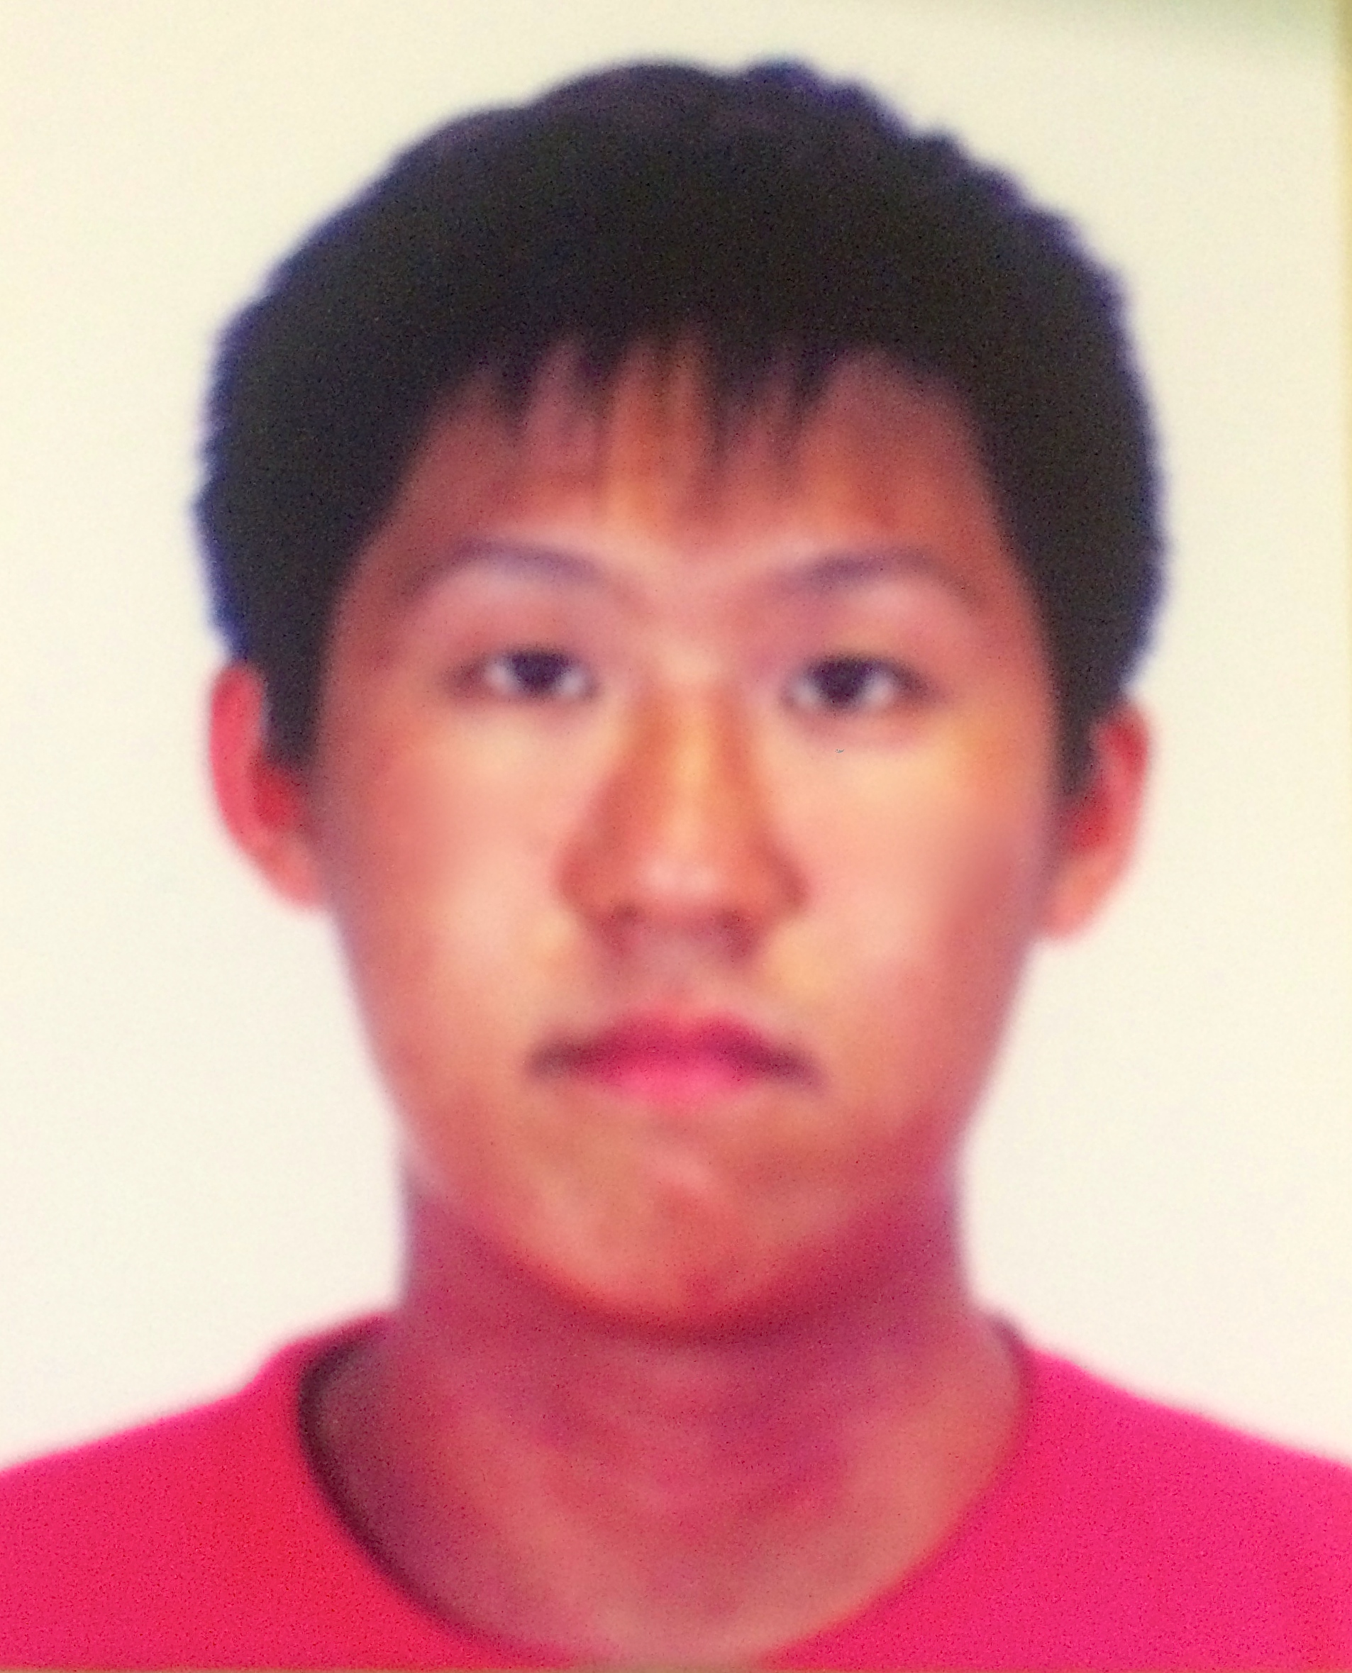  (have glasses in class)

Code
#include <iostream>
#include <string>
#include <fstream>
#include <vector>
using namespace std;

void printErrorMsg(string msg){
vector<string> data;
cout << "Error: " << msg << endl;
}

bool checkFile(int n){
if (n < 2){
return false;
}
return true;
}
string getFile(){
string s;
cout << "file:";
cin >> s;
return s;
}

vector<string> readFile(string file){
fstream myfile;
vector<string> data;
string line;
myfile.open(file, ios::in || ios::out);
while (getline(myfile, line)){
data.push_back(line);
}
myfile.close();
return data;
}

void printIntro(string file){
cout << "Welcome to TextBuddy. " << file << " is ready for use\n";
}

string requestCommand(){
string cmd;
cout << "command: ";
cin >> cmd;
return cmd;
}

vector<string> add(vector<string> &data, string file){
string line;
getline(cin, line);
cout << "Added to " << file << ": " << line << endl;
data.push_back(line.substr(1, string::npos));
return data;
}

vector<string> del(vector<string> &data, string file){
unsigned int linenum;
std::cin >> linenum;
if (linenum <= data.size() && linenum > 0){
cout << "Removed from " << file << ": " << data[linenum - 1] << endl;
data.erase(data.begin() + linenum - 1);
}

return data;
}

vector<string> clear(vector<string> &data, string file){
data.clear();
cout << "All content deleted from " << file << endl;
return data;
}

void print_data(vector<string> &data){
for (unsigned int i = 0; i < data.size(); i++){
cout << i + 1 << ". " << data[i] << endl;
}
}

void display(vector<string> data, string file){
if (data.empty()){
printErrorMsg(file + " is empty");
}
else{
print_data(data);
}
}

vector<string> commandInput(string cmd, vector<string> &data, string file){
if (cmd == "add"){
data = add(data, file);
}
else if (cmd == "delete"){
data = del(data, file);
}
else if (cmd == "clear"){
data = clear(data, file);
}
else if (cmd == "display"){
display(data, file);
}
else if (cmd == "exit"){
NULL;
}
else{
string burnline;
getline(cin,burnline);
printErrorMsg("Command not recognised");
}
return data;
}

void saveData(vector<string> &data, string file){
fstream myfile;
myfile.open(file, std::ios::trunc | std::ios::out);
for (unsigned int i = 0; i < data.size(); i++){
myfile << data[i] << std::endl;
}
myfile.close();
}

void loop(vector<string> &data, string file){
string cmd = "";
while(cmd != "exit"){
cmd = requestCommand();
data = commandInput(cmd, data, file);
saveData(data, file);
}
}

int main(int argc, char* argv[])
{
string file;
vector<string> data;

file = argv[1];

data = readFile(file);

printIntro(file);
loop(data, file);
return 1;
}

TestInput.txt
Textbuddy.exe mytextfile.txt
add cookies is good
display
add I'm Hungry
display
delete 2
display
clear
display
exit

ExpectedOutput.txt
Welcome to TextBuddy. mytextfile.txt is ready for use
command: add little brown fox
added to mytextfile.txt: “cookies is good”
command: display
1. cookies is good
command: add I'm Hungry
added to mytextfile.txt: “I'm Hungry"
command: display
1. cookies is good
2. I'm Hungry
command: delete 2
deleted from mytextfile.txt: “I'm Hungry”
command: display
1. cookies is good
command: clear
all content deleted from mytextfile.txt
command: display
mytextfile.txt is empty
command: exit

